**SQL MURDER MYSTERY**

1. **USE CASE:** Type of Crime Scene in city NYC

**QUERY:** select type from crime_scene_report where city= 'NYC'

**SCREENSHOT:**

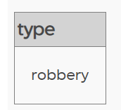

1. **USE CASE:** Number of persons who have the membership status as gold in a gym

**QUERY:** select count (Distinct person_id) from get_fit_now_member where membership_status='gold'

**SCREENSHOT:**

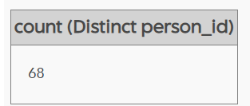

1. **USE CASE:** Counting the ids which have been used for the making of driving license in the descending order

**QUERY:** select id, count (*) from drivers_license group by id Order by 2 desc limit 5

**SCREENSHOT:**

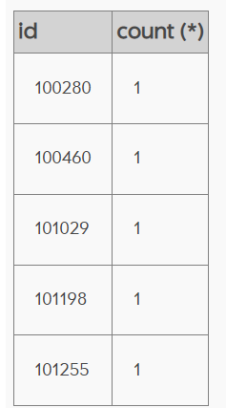

1. **USE CASE:** Finding out the distinct events which took place when the persons of a particular id went

**QUERY:** select distinct event_name from facebook_event_checkin where person_id = '82998'

**SCREENSHOT:**

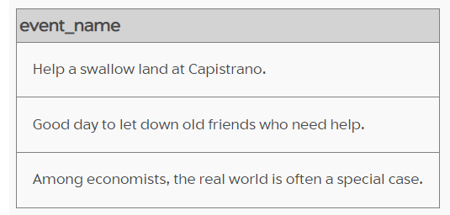

1. **USE CASE:** Selecting the Social Security Number of the person whose income is between the particular range

**QUERY:** select ssn from income WHERE annual_income BETWEEN '9000' AND '10000'

**SCREENSHOT:**

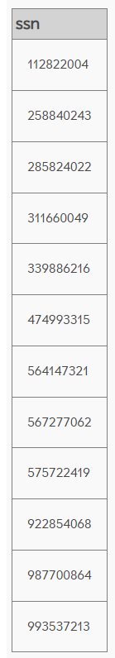

1. **USE CASE:** Joining two tables with a person id as a common column

**QUERY:** select * from facebook_event_checkin inner join person on facebook_event_checkin.person_id=person.id limit 5

**SCREENSHOT:**

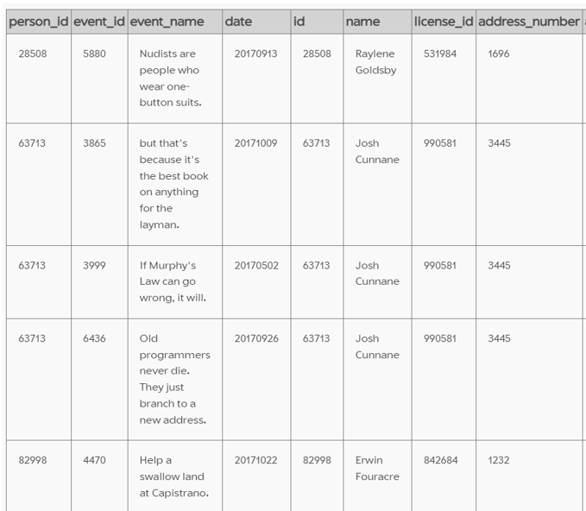 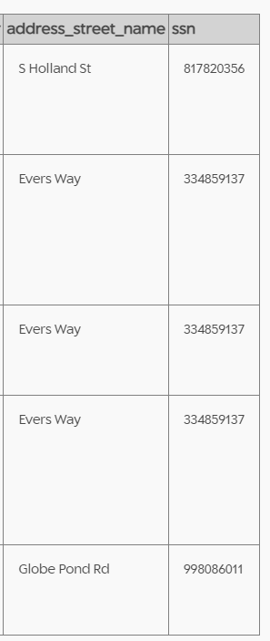

1. **USE CASE:** Joining two tables with ssn as a common column

**QUERY:** Select name from person left join income on person.ssn=income.ssn WHERE annual_income>450000

**SCREENSHOT:**

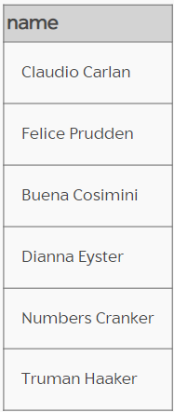

1. **USE CASE:** Joining two tables with id as a common column

**QUERY:** select address_number, address_street_name from person join get_fit_now_member on person.id=get_fit_now_member.id

**SCREENSHOT:**

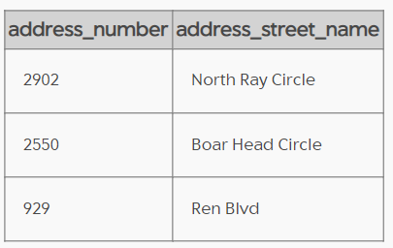

1. **USE CASE:** Joining two tables with name and id as a common column

**QUERY:** SELECT gender, eye_color, hair_color, car_model

FROM get_fit_now_member

JOIN person

ON get_fit_now_member.name = person.name

JOIN drivers_license dl

ON person.license_id = dl.id

where car_model= 'M3'

**SCREENSHOT:**

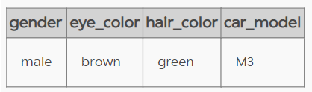

1. **USE CASE:** Joining two tables with date as a common column

**QUERY:** SELECT type, description

FROM crime_scene_report

JOIN facebook_event_checkin

ON crime_scene_report.date = facebook_event_checkin.date

where type='arson' limit 5

**SCREENSHOT:**

